A
PROJECT BASED LAB REPORT
On
Modified DES Cipher with Avalanche Effect
Submitted in partial fulfilment of the
Requirements for the award of the Degree of
Bachelor of Technology
In
Computer Science & Engineering
By

T.V.L.Vaishnavi  (12003524) | G.Vyshnavi  (12003052)
Dorothy William.N  (12003573) | N.Likitha  (12003596)



DEPARTMENT OF COMPUTER SCIENCE & ENGINEERING
K L University
Green Fields, Vaddeswaram, Guntur District-522 502
2014-2015

K L University

DEPARTMENT OF COMPUTER SCIENCE & ENGINEERING

CERTIFICATE

This is to certify that this project based lab report entitled “Modified DES Cipher with
Avalanche Effect” is a bonafide work done by T.V.L.Vaishnavi(12003524) , G.Vyshnavi(12003052), Dorothy William.N(12003573) and N.Likitha (12003596) in partial fulfillment of the requirement for the award of degree in BACHELOR OF TECHNOLOGY in Computer Science and Engineering during the academic year 2014-
2015.

Lecturer In Charge Head of the Department
Mr.A.V.Praveen Krishna Dr.K.Thirupathi Rao
(Assistant.Professor) (Professor)
K L University

DEPARTMENT OF COMPUTER SCIENCE & ENGINEERING

DECLARATION

We hereby declare that this project based lab report entitled “Modified DES Cipher with Avalanche Effect “has been prepared by us in partial fulfilment of the requirement for the award of degree “BACHELOR OF TECHNOLOGY in COMPUTER SCIENCE & ENGINEERING” during the academic year 2014-2015.
We also declare that this project based lab report is of our own effort and it has not been submitted to any other university for the award of any degree.

Date: 06-11-2014 T.V.L.Vaishnavi(12003524)

Place: Vaddeswaram G.Vyshnavi (12003052)

Dorothy William.N(12003573)

N.Likitha(12003596)
ACKNOWLEDGEMENTS

My sincere thanks to Mr.A.V.Praveen Krishna, in the Lab for their outstanding support throughout the project for the successful completion of the work
We express our gratitude to Dr.K.Thirupathi Rao, Head of the Department for Computer Science and Engineering for providing us with adequate facilities, ways and means by which we are able to complete this project work.
We would like to place on record the deep sense of gratitude to the Honble Vice Chancellor, K L University for providing the necessary facilities to carry the concluded project work.
Last but not the least, we thank all Teaching and Non-Teaching Staff of our department and especially our classmates and friends for their support in the completion of our project work.

T.V.L.Vaishnavi(12003524)

G.Vyshnavi (12003052)

Dorothy William.N(12003573)

N.Likitha(12003596)

CONTENTS
Content |  | Pg. No
1. | Project Description | 1
 | - Defining and initializing all Required functions & Description of the Module | 3
 | 1.2 Key Generation Phase & Description of the Module  &Description of the Module | 3
 | 1.3 Encryption Phase &Description of the Module | 3
 | 1.4 Decryption Phase &Description of the Module | 4
2. | Block Diagram | 5
3. | Source Code | 6
4. | Snapshots of the outputs | 14
5. | References | 17

ABSTRACT

The principal goal guiding the design of any encryption algorithm must be security against unauthorized attacks. Within the last decade, there has been a vast increase in the accumulation and communication of digital computer data in both the private and public sectors. Much of this information has a significant value, either directly or indirectly, which requires protection. The algorithms uniquely define the mathematical steps required to transform data into a cryptographic cipher and also to transform the cipher back to the original form. Performance and security level is the main characteristics that differentiate one encryption algorithm from another. Here introduces a new method to enhance the performance of the Data Encryption Standard (DES) algorithm is introduced here. This is done by replacing the predefined XOR operation applied during the 16 round of the standard algorithm by a new operation depends on using two keys, each key consists of a combination of 4 states (0, 1, 2, 3) instead of the ordinary 2 state key (0, 1). This replacement adds a new level of protection strength and more robustness against breaking methods.

INTRODUCTION

Cryptography is usually referred to as the study of secret‖, while now a days is most attached to the definition of encryption. Encryption is the process of converting plain text unhidden‖ to a cryptic text hidden‖ to secure it against data thieves. This process has another part where cryptic text needs to be decrypted on the other end to be understood. Encryption is becoming a vital process to ensure security over the wireless channel. However, using well-known encryption algorithms to encrypt data in wireless communication results in a catastrophic error because of the avalanche effect, which is an inherited criterion to ensure security. Although this criterion is desirable, these algorithms do not take into account the error characteristics of the wireless channel. Therefore, if an error occurs in the encrypted data over the channel, the decryption process at the receiver results in half the original bits to be in error because of this criterion. Hence, the need for a new secure encryption algorithm that takes into account the error characteristics of the wireless channel becomes necessary. In this paper, we propose a modification to the data encryption standard (DES) to make it secure and immune to errors caused by the wireless channel. We observe that using the modified algorithm in wireless channels improves the bit error rate performance as well as security compared with DES. We consider an additive white Gaussian noise with fading and evaluate the performance of the proposed algorithm in terms of bit error rate. We also show that the proposed algorithm is secure as compared with DES.

1. PROJECT DESCRIPTION

The 16-round Feistel network, which constitutes the cryptographic core of DES, splits the 64- bit data blocks into two 32-bit words, L Block and R Block (denoted by L0 and R0). In each iteration (or round), the second word Ri is fed to a function f and the result is added to the first word Li. Then both words are swapped and the algorithm proceeds to the next iteration. The function f of DES algorithm is key dependent and consists of 4 stages.

1. Expansion (E): The 32-bit input word is first expanded to 48 bits by duplicating and reordering half of the bits.[11]
2. Key mixing: The expanded word is XOR’ed with a round key constructed by selecting 48 bits from the 56-bit secret key, a different selection is used in each round.
3. Substitution: The 48-bit result is split into eight 6-bit words which are substituted in eight parallel 6×4-bit S-boxes. All eight S-boxes are different but have the same special structure.
4. Permutation (P)
: The resulting 32 bits are reordered according to a fixed permutation before being sent to the output.
The modified R Block is then XORED with L Block and the resultant fed to the next R Block register. The unmodified R Block is fed to the next L Block register. With another 56 bit derivative of the 64 bit key, the same process is repeated.

MODULES

Our project contains four modules .The four modules are as follows:

Module 1: Defining & Initialization of all required functions required for DES
Module 2: Key Generation Phase
Module 3: Encryption Phase
Module 4: Decryption Phase

1.1 Defining & Initialization of all required functions required for DES

Module 1:

Task 1: Defining Initial Permutation and Inverse IP functions
Task 2: Defining Expansion & Permutation function
Task 3: Defining S-Box Function
Task 4: Defining PC-1 and PC-2
Task 5: Defining Shift Key function
Task 6: Defining Initial Key & Plain text input of 64- bits
Task 7: Defining the other constant functions require for DES implementation

1.2 Key Generation Phase

Module 2:

Task 1: Generate an input sequence 64-bit input number for key generation
Task 2: Implementing Permuted Choice – 1 function on 64-bit number
Task 3: Implementing Shift operation on the output from PC-1 function
Task 4: Implementing Permuted Choice – 2 function
Task 5: Generate the keys require for encryption function
Task 6: Generate the keys require for decryption function module

1.3 Encryption Phase

Module3:
Task 1: Generate an input sequence 64-bit input number for encryption
Task 2: Implementing Initial Permutation function on 64-bit number
Task 3: Implementing Expansion function on 32 bit number to get 48-bit number Task 4: Implementing XOR on 48 bit with Round 1 key
Task 5: Implementing S- Box function on 48 bit number to get 32 – bit number Task 6: Implementing Permutation function on 32- bit
Task 7: Generate the output bit effect with varying 1, 2, and 3 bits in the input.

1.4 Decryption Phase

Module 4:
Task 1: Generate an input sequence 64-bit input number for decryption
Task 2: Implementing IP⁻¹ Inverse Initial Permutation function on 64-bit number
Task 3: Implementing Expansion function on 32 bit number to get 48-bit number
Task 4: Implementing XOR on 48 bit with Round 1 key
Task 5: Implementing S- Box function on 48 bit number to get 32 – bit number
Task 6: Implementing Permutation function on 32- bit

2. BLOCK DIAGRAM

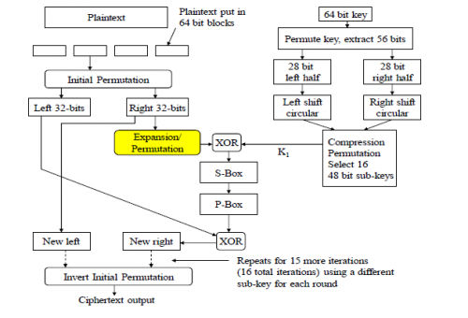

3. Source Code

#include <stdio.h>
#include <math.h>
int l[32],r[32],keys[16][48],ct[64],ct1[64],s,w,q,v=0,ch,p,t=0;
void left_shift(int keyip[],int nob) //Left shift nob bits.. (nob - No. of Bits)
{
int t1,t2,i;
while(nob>0)
{
t1=keyip[0],t2=keyip[28];
for(i=0;i<55;i++)
if(i==27) continue;
else
keyip[i]=keyip[i+1];
keyip[27]=t1,keyip[55]=t2;
nob--;
}
}

void gen_keys()//Generating keys. . .
{
int key[64]={1,0,1,0,1,1,1,1,1,0,
0,1,0,1,0,0,0,1,0,1,
1,1,1,0,1,0,1,0,1,1,
1,1,1,1,0,0,0,0,0,1,
0,0,0,1,0,1,0,1,0,1,
1,0,1,0,0,0,1,1,1,0,
1,0,1,0};
int keyip[56],i=0,j,z,t;
int pc1[]={57,49,41,33,25,17,9,1,58,50,42,34,26,18,10,2,59,51,43,35,27,19,11,3,60,52,44,36,63,55,47,39,31,23,15,7,62,54,46,38,30,22,14,6,61,53,45,37,29,21,13,5,28,20,12,4}; //Permuted Choice 1
int pc2[]={14,17,11,24,1,5,3,28,15,6,21,10,23,19,12,4,26,8,16,7,27,20,13,2,41,52,31,37,47,55,30,40,51,45,33,48,44,49,39,56,34,53,46,42,50,36,29,32}; //Permuted Choice 2
int left_shift_s[]={1,2,3,4,5,6,7,8,9,10,11,12,13,14,15}; //Schedule of Lift Shifts
t++;

if(ch==2)
{
for(i=0;i<t;i++)
{
if( key[t]==1)
key[t]=0;
else
key[t]=1;
}
}

// printf("Enter Key binary 64 bit:");
// for(i=0;i<64;i++)
// scanf("%d",key[i]);
printf("\n given key is\t");
for(i=0;i<64;i++)
printf("%d",key[i]);
printf("\n\n");
for(i=0;i<56;i++) // Permuted Choice 1
keyip[i] = key[pc1[i]-1];
for(j=0;j<16;j++)
{

left_shift(keyip,left_shift_s[j]);
for(i=0;i<48;i++)
keys[j][i]=keyip[pc2[i]-1]; //Permuted Choice 2

}
}
void sbox(int row,int col,int i,int p[],int loc)
{
int sop,j,sbox[8][4][16]={14,4,13,1,2,15,11,8,3,10,6,12,5,9,0,7,0,15,7,4,14,2,13,1,10,6,12,11,9,5,3,8,4,1,14,8,13,6,2,11,15,12,9,7,3,10,5,0,15,12,8,2,4,9,1,7,5,11,3,14,10,0,6,13, //64 values - SBox1
15,1,8,14,6,11,3,4,9,7,2,13,12,0,5,10,3,13,4,7,15,2,8,14,12,0,1,10,6,9,11,5,0,14,7,11,10,4,13,1,5,8,12,6,9,3,2,15,13,8,10,1,3,15,4,2,11,6,7,12,0,5,14,9, //SBox2
10,0,9,14,6,3,15,5,1,13,12,7,11,4,2,8,13,7,0,9,3,4,6,10,2,8,5,14,12,11,15,1,13,6,4,9,8,15,3,0,11,1,2,12,5,10,14,7,1,10,13,0,6,9,8,7,4,15,14,3,11,5,2,12, //SBox3
7,13,14,3,0,6,9,10,1,2,8,5,11,12,4,15,13,8,11,5,6,15,0,3,4,7,2,12,1,10,14,9,10,6,9,0,12,11,7,13,15,1,3,14,5,2,8,4,3,15,0,6,10,1,13,8,9,4,5,11,12,7,2,14, //SBox4
2,12,4,1,7,10,11,6,8,5,3,15,13,0,14,9,14,11,2,12,4,7,13,1,5,0,15,10,3,9,8,6,4,2,1,11,10,13,7,8,15,9,12,5,6,3,0,14,11,8,12,7,1,14,2,13,6,15,0,9,10,4,5,3, //SBox5
12,1,10,15,9,2,6,8,0,13,3,4,14,7,5,11,10,15,4,2,7,12,9,5,6,1,12,14,0,11,3,8,9,14,15,5,2,8,12,3,7,0,4,10,1,13,11,6,4,3,2,12,9,5,15,10,11,14,1,7,6,0,8,13, //SBox6
4,11,2,14,15,0,8,13,3,12,9,7,5,10,6,1,13,0,11,7,4,9,1,10,14,3,5,12,2,15,8,6,1,4,11,13,12,3,7,14,10,15,6,8,0,5,9,2,6,11,13,8,1,4,10,7,9,5,0,15,14,2,3,12, //SBox7
13,2,8,4,6,15,11,1,10,9,3,14,5,0,12,7,1,15,13,8,10,3,7,4,12,5,6,11,0,14,9,2,7,11,4,1,9,12,14,2,0,6,10,13,15,3,5,8,2,1,14,7,4,10,8,13,15,12,9,0,3,5,6,11}; //SBox8
sop = sbox[i][row][col]; // i value gives SBox Number
for(;sop!=0;sop/=2)
p[loc--]=sop%2;
}
void cmp_fun(int round) // Complex Function . .
{
int E[]={32,1,2,3,4,5,4,5,6,7,8,9,8,9,10,11,12,13,12,13,14,15,16,17,16,17,18,19,20,21,20,21,22,23,24,25,24,25,26,27,28,29,28,29,30,31,32,1}; //Expansion Permutation (E)
int Per[]={16,7,20,21,29,12,28,17,1,15,23,26,5,18,31,10,2,8,24,14,32,27,3,9,19,13,30,6,22,11,4,25}; //Permutation Function (P)
int eo[48],i,j,k,p[32]={0},np[32],sip[8][6],row,col;
for(i=0;i<48;i++)//Expansion Permutation (E)
eo[i] = r[E[i]-1];
j=0,k=0;
for(i=0;i<48;i++) // Performing Xor with Keys
{
sip[j][k] = eo[i]^keys[round][i];//round value gives Key Number
k++;
if(k==6)// 6 coz, using 6 bits as S-Box input
k=0,j++;
}
for(i=0;i<8;i++) // Calling 8 SBoxes
{
row = sip[i][0]*2 + sip[i][5];
for(j=0;j<4;j++)
col += sip[i][j+1]*pow(2,(3-j));
sbox(row,col,i,p,(4*(i+1)-1)); //p[] stores Sbox Output ;; (4*(i+1)-1) gives the index in p[], to store the SBox Output
}
for(i=0;i<32;i++) // Permutation Function P
np[i]=p[Per[i]-1];
for(i=0;i<32;i++) // Xor with left bits
l[i] = l[i]^np[i];
}
void main()
{
int pt[64]={1,0,1,0,1,1,1,1,1,0,
0,1,0,1,0,0,0,1,0,1,
1,1,1,0,1,0,1,0,1,1,
1,1,1,1,0,0,0,0,0,1,
0,0,0,1,0,1,0,1,0,1,
1,0,1,0,0,0,1,1,1,0,
1,0,1,0};
int i,t[64],j;
int ip[] ={58,50,42,34,26,18,10,2,60,52,44,36,28,20,12,4,62,54,46,38,30,22,14,6,64,56,48,40,32,24,16,8,57,49,41,33,25,17,9,1,59,51,43,35,27,19,11,3,61,53,45,37,29,21,13,5,63,55,47,39,31,23,15,7}; //Initail Permutation (IP)
int iip[]={40,8,48,16,56,24,64,32,39,7,47,15,55,23,63,31,38,6,46,14,54,22,62,30,37,5,45,13,53,21,61,29,36,4,44,12,52,20,60,28,35,3,43,11,51,19,59,27,34,2,42,10,50,18,58,26,33,1,41,9,49,17,57,25};//Inverse Initial Permutation (IP^-1)
clrscr();
printf("\n WELCOME TO MODIFIED DES WITH AVALANCHE EFFECT-12th PROJECT");
printf("\n 1.AVALANCHE EFFECT WITH CHANGING BITS IN PLAIN TEXT");

printf("\n 2.AVALANCHE EFFECT WITH CHANGING BITS IN KEY");
printf("\n enter your choice here:\t");
scanf("%d",&ch);
gen_keys();
//printf("Enter Plain Text in binary (64 bit)");
//for(i=0;i<64;i++)
//scanf("%d",pt[i]);
printf("\nPlain Text\n");
for(i=0;i<64;i++)
printf("%d",pt[i]);

for(i=0;i<64;i++) //Initial Permutatiion on Plain text
if(i<32)
l[i] = pt[ip[i]-1];
else
r[i-32] = pt[ip[i]-1];

for(i=0;i<16;i++)
{
cmp_fun(i); //Complex Function Round i
if(i<15) //Not Swapping for Round 16
for(j=0;j<32;j++) //Swapping left & right
r[j]=l[j]+r[j],l[j]=r[j]-l[j],r[j]=r[j]-l[j];
}
for(p=0;p<64;p++)
if(p<32) t[p]=l[p];
else t[p]=r[p-32];

for(i=0;i<64;i++)// Inverse Intial Permutation, ct -> Cipher Text
ct1[i]=t[iip[i]-1];
//bit changing process in plaintext
for(q=0;q<22;q++)
{
if(ch==1)
{
for(s=0;s<q;s++)
{
if(pt[s]==0)
pt[s]=1;
else
pt[s]=0;
}
}
for(i=0;i<64;i++) //Initial Permutatiion on Plain text
if(i<32)
l[i] = pt[ip[i]-1];
else
r[i-32] = pt[ip[i]-1];

for(i=0;i<16;i++)
{
cmp_fun(i); //Complex Function Round i
if(i<4) //Not Swapping for Round 5
for(j=0;j<32;j++) //Swapping left & right
r[j]=l[j]+r[j],l[j]=r[j]-l[j],r[j]=r[j]-l[j];
}
for(p=0;p<64;p++)
if(p<32) t[p]=l[p];
else t[p]=r[p-32];

for(i=0;i<64;i++)// Inverse Intial Permutation, ct -> Cipher Text
ct[i]=t[iip[i]-1];
if(ch==1)
{
for( w=0;w<64;w++)
{
if(ct[w]!=ct1[w])
v++;
}
printf("\n no of bits changed in PT:%d\t\tno of bits changed in CT: %d",q+1,v%64);
}
if(ch==2)
{
for( w=0;w<64;w++)
{
if(ct[w]!=ct1[w])
v++;
}
printf("\n no of bits changed in key:%d\t\tno of bits changed in CT: %d",q+1,v%64);
}
}

}

4. SCREEN SHOTS

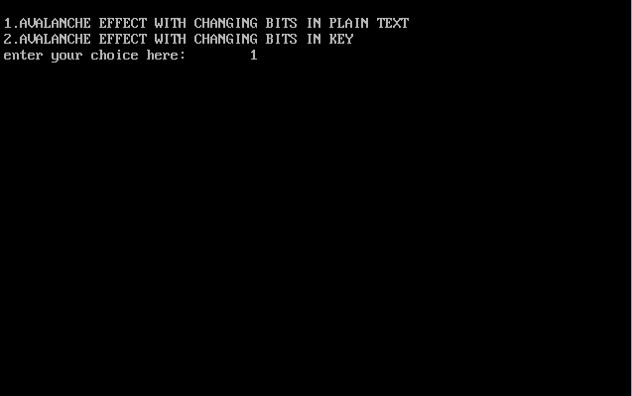
SCREENSHOT-1: Menu Driven Output with 1st option for analysing avalanche effect with changing bits in plain text and 2nd option for analysing avalanche effect with changging bits in key.

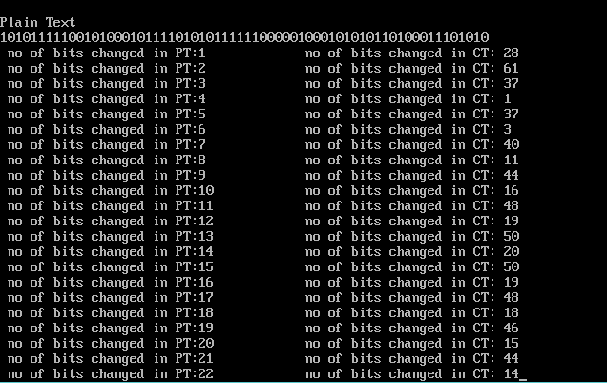
SCREENSHOT 2: Avalanche effect with respect to number of bits being changed in plaintext.
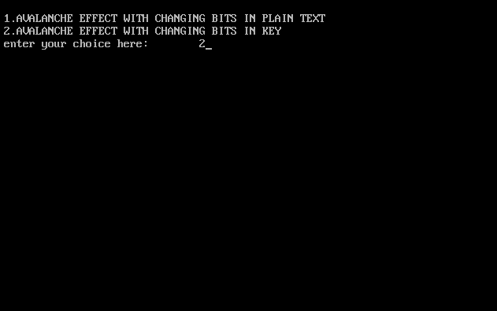
SCREEN SHOT-3: Selecting option 2
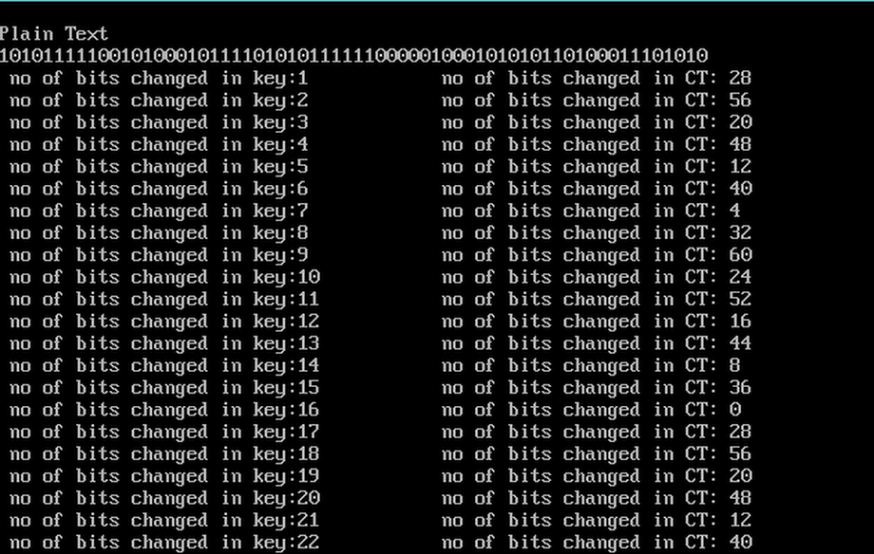
SCREEN SHOT 4:Avalanche effect with respect bits being changed in key.

5. REFERENCES

- “Cryptography and Network Security principles and practices” by William Stallings published by printorson & Pearson, 5th edition.
- “Network Security Essentials” by William Stallings published by prentices hall , 5th edition
- “Computer Security principles and practise” by William Stallings published by pearson,2 edition

WEBSITES :
- http://crypto.stackexchange.com/questions/1164/avalanche-effect-in-des
- http://www.iosrjournals.org/iosr-jce/papers/Vol7-Issue4/A0740107.pdf

